Best Practices for Screening non-Employees
Set-Up
Secure doors to all other than Staff, and create a partition to funnel everyone directly to screening station. Use signage to set expectations for those entering the building.

Attitude and Implementation
If you are nervous, the person being screened will be nervous. Signage has made them aware of entry requirements so be confident during the process. If you know the person, use that relationship. If the person is unknown to you, be matter of fact and authoritative with the process. They will appreciate your confidence.

Supplies
Sign-In sheets Sanitizer Pens New & Used Pen Cups
Thermometer Alcohol wipes Stickers

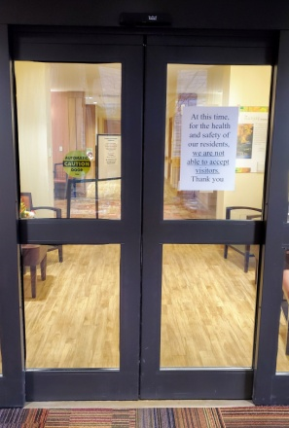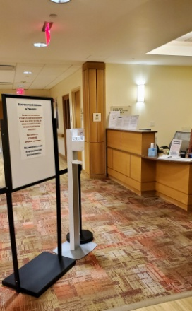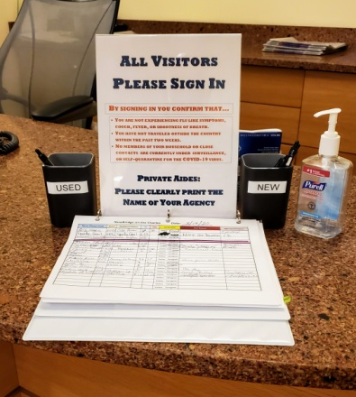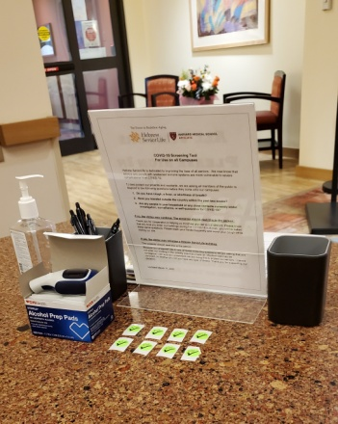
Screening protocol
From a safe distance (currently recommended at 6’), ask the following questions.
- Do you have any symptoms of respiratory infection such as fever, cough, shortness of breath, or a sore throat?
- Have you travelled to a country outside of the United States in the last 14 days?
- Have you had close contact with anyone under investigation, surveillance, or self-quarantine for COVID-19?
Once “Screening Questions” are answered move closer to do the temperature screening.
- Follow instruction for the specific thermometer your desk is utilizing.
  - If thermometer requires contact make sure to wipe with an alcohol prep pad.
- If temperature screening is within range (below 100.4) provide a sticker with the date.
- If temperature is 100.4 or above instruct them to leave the building immediately and contact housekeeping to clean and sanitize the area.
- Entrant must sign in, answering all boxes, with a pen from the new cup and place it in the used cup after use to be sanitized.
- Provide “Caregiver Notice” to be reviewed at the desk, and have them sign “Caregiver Protocol Log”.
- Provide any site specific instructions about movement within the community.

Maintaining the Screening stations
- Clean pens from the “Used” cup with an alcohol wipe or sanitizer and place back in the “New” cup.
- Pre-cut stickers and date for quick delivery and to limit contact with sticker roll.

*Note: Employees should be screened for temperature only, having been directed to self-screen with the rest of the questions

